How to get here?
Venue
Institute of Experimental Botany, Czech Academy of Sciences (UEB)
Building B1, Rozvojová 263, 165 00 Praha 6 – Lysolaje
Website and program: https://ueb.cas.cz/en/news/?id=2289&s=multimodal-light-microscopy-imaging-in-plant-research-registration-is-open-1
How to get here
From metro line A (Dejvická), take bus 107 or 147 to Kamýcká. It’s then about a 5-minute walk.
Please use the map below—it shows the exact route from the stop to Building B1 inside the campus.
Gate information
At the gatehouse, you may be asked to show ID and sign the guest book. Please mention you’re attending the “Multimodal Light Microscopy Imaging in Plant Research” workshop in UEB Building B1.
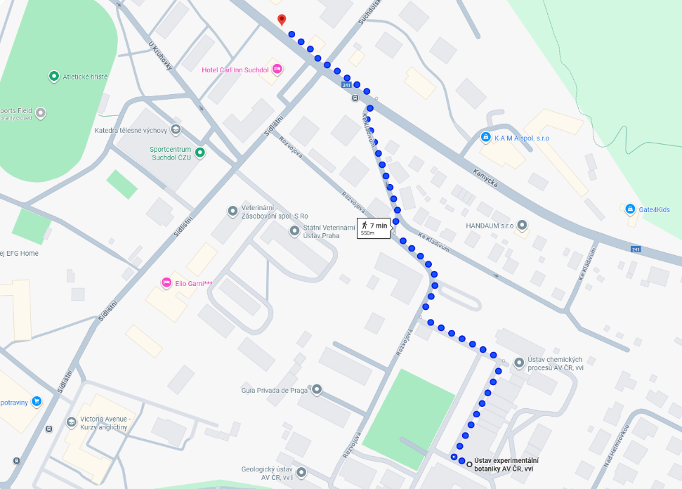
Once inside, simply follow the signs to Building B1—the workshop takes place on the ground floor.

